EXPLORATORY TESTING REPORT
ShopEase – E-Commerce Web Application
Prepared by: Bhairavsinh Devda | Week 2 Deliverable

1. Test Charter
This charter defines the mission and boundaries for the exploratory testing sessions conducted this week. Unlike scripted testing, exploratory testing is intentionally unscripted — the tester actively investigates the application, forming and revising hypotheses about where defects are likely to hide as new information is discovered.
Mission | Explore ShopEase's cart, checkout, coupon, search, and wishlist features to uncover usability, functional, and edge-case defects not covered by scripted test cases.
Areas to Explore | Cart & Coupons | Checkout (incl. mobile layout) | Product Search & Wishlist
Out of Areas | Payment gateway internals, seller-side tools, load/performance testing
Techniques | Boundary probing, invalid/unexpected input, rapid repeated actions, cross-device resizing, interrupted flows
Time-box | Approx. 6 hours across 3 sessions (2 hours each)
Tester | Matrix (Junior QA Analyst)

2. Exploratory Testing Sessions

Session 1 — Cart & Coupon Behaviour
Duration: 2 hours | Focus: Cart totals, quantity edge cases, and coupon code handling under repeated/unusual actions.
Approach
- Added items to cart, then rapidly double-clicked 'Apply Coupon' to see if the discount could be applied more than once.
- Tried increasing item quantity past visible stock limits using the '+' button held down repeatedly.
- Applied a coupon, then removed the discounted item to check whether the discount amount updated correctly.
- Opened the cart in two browser tabs and modified quantity in one to check if the other tab reflected the change.
Observations
The coupon logic appears to lack a duplicate-application guard on rapid double-clicks. Quantity increments beyond stock were inconsistently blocked depending on how fast the '+' button was clicked. Cross-tab cart state did not sync until a manual page refresh.

Session 2 — Search, Filters & Wishlist
Duration: 2 hours | Focus: Search input handling, filter combinations, and wishlist state persistence.
Approach
- Entered special characters, emojis, and very long strings into the search bar.
- Combined multiple filters (price range + category + sort) to check for conflicting or empty results.
- Added and removed the same product from the wishlist multiple times in quick succession.
- Removed a wishlist item from one page (product page) and checked if the Wishlist page icon updated without a refresh.
Observations
Special-character search input triggered a server error rather than a graceful 'no results' response. Filter combinations mostly worked, though clearing one filter sometimes reset the others unexpectedly. Wishlist icon state did not consistently reflect removal actions performed elsewhere in the app.

Session 3 — Checkout Flow & Mobile Responsiveness
Duration: 2 hours | Focus: Checkout form behaviour, price consistency, and layout at mobile screen widths.
Approach
- Compared displayed prices on the product page against the price shown later in the cart and checkout.
- Entered a script-like string into the delivery address field to check input sanitisation.
- Resized the browser to a 375px mobile width and walked through the full checkout flow.
- Attempted to navigate back and forward through checkout steps using the browser's back button mid-flow.
Observations
A price discrepancy was found between the product listing and the cart total for at least one product. The address field appeared to accept unescaped script-like input without visible sanitisation feedback. At 375px width, the 'Place Order' button was partially clipped below the visible viewport, requiring extra scrolling that wasn't obviously indicated.

3. Bug Reports
BUG-01 — Coupon discount applies twice on rapid double-click
Field | Value | Field | Value
Severity | Major | Priority | High
Module | Cart / Coupons | Environment | Chrome, Desktop
Session | Session 1 | Status | Open

Description
Rapidly double-clicking the 'Apply Coupon' button applies the same discount twice, incorrectly reducing the order total beyond the intended discount.
Steps to Reproduce
1. Add items to the cart totaling above the coupon's minimum order value.
2. Enter a valid coupon code (e.g., SAVE10) in the coupon field.
3. Rapidly double-click the 'Apply Coupon' button.
4. Observe the cart summary.
Expected Result
The coupon should be applied once, and a second application attempt should either be blocked or show 'coupon already applied'.
Actual Result
The discount line appears twice in the cart summary and the total is reduced by double the intended amount.
Evidence
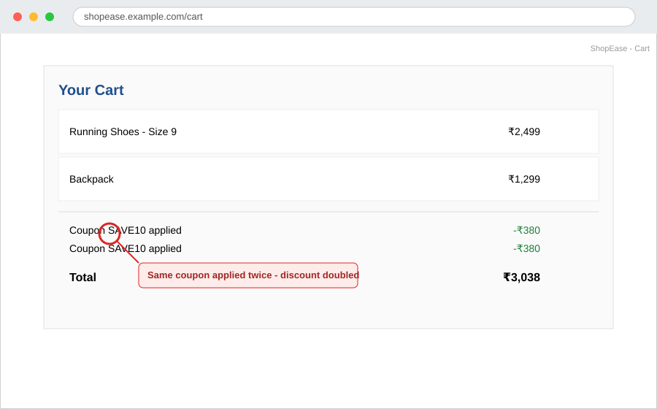
Figure 1 — Coupon SAVE10 applied twice, discount stacked incorrectly.
BUG-02 — Price mismatch between product page and cart
Field | Value | Field | Value
Severity | Critical | Priority | High
Module | Product / Cart | Environment | Chrome, Desktop
Session | Session 3 | Status | Open

Description
The price shown on the product detail page does not match the price charged for the same item once it reaches the cart, creating a pricing inconsistency that could affect customer trust and order accuracy.
Steps to Reproduce
1. Open a product detail page and note the listed price (e.g., ₹1,999 for Wireless Headphones).
2. Add the product to the cart.
3. Open the cart page and check the price shown for the same item.
Expected Result
The price shown in the cart should exactly match the price shown on the product page at the time of adding to cart.
Actual Result
The cart displays a higher price (₹2,249) than the product page (₹1,999) for the same item and variant.
Evidence
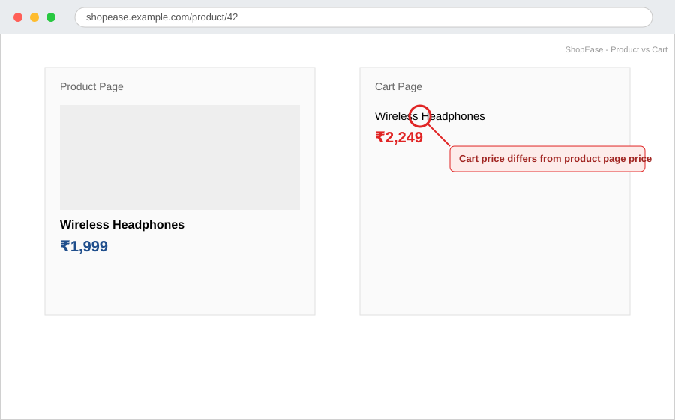
Figure 2 — Product page price vs. cart price for the same item.
BUG-03 — 'Place Order' button partially clipped on mobile (375px) checkout
Field | Value | Field | Value
Severity | Major | Priority | Medium
Module | Checkout / Responsiveness | Environment | Chrome, mobile emulation, 375px width
Session | Session 3 | Status | Open

Description
On narrow mobile viewports, the 'Place Order' button at the bottom of the checkout page is partially cut off, making it harder for users to notice and tap without extra scrolling.
Steps to Reproduce
1. Open the checkout page in a browser set to 375px viewport width (or an equivalent mobile device).
2. Scroll to the bottom of the checkout form.
3. Observe the position and visibility of the 'Place Order' button.
Expected Result
The 'Place Order' button should be fully visible and comfortably tappable within the viewport, ideally without requiring additional scrolling beyond the natural form flow.
Actual Result
The button extends beyond the visible viewport edge and is partially clipped, with no clear visual cue prompting the user to scroll further.
Evidence
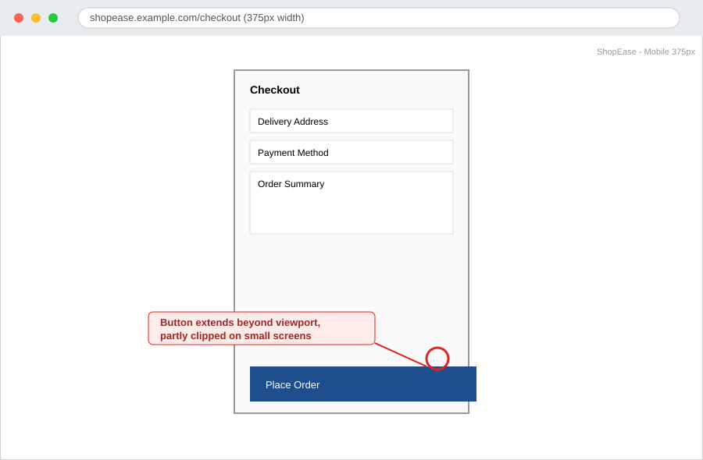
Figure 3 — Checkout screen at 375px width; button partially clipped.
BUG-04 — Wishlist heart icon doesn't update after item removal
Field | Value | Field | Value
Severity | Minor | Priority | Low
Module | Wishlist | Environment | Chrome, Desktop
Session | Session 2 | Status | Open

Description
After removing an item from the wishlist via the product page, the heart/wishlist icon on that product remains visually 'filled' (indicating it's still wishlisted) even though the Wishlist page correctly shows the item as removed.
Steps to Reproduce
1. Add a product to the wishlist from its product page (heart icon becomes filled).
2. Navigate to the Wishlist page and remove the item from there.
3. Return to the product's page without refreshing the browser.
4. Observe the state of the heart/wishlist icon.
Expected Result
The heart icon on the product page should reflect the current wishlist state (unfilled) immediately after removal, without requiring a manual page refresh.
Actual Result
The heart icon remains filled on the product page despite the item no longer being in the wishlist, until the page is manually refreshed.
Evidence
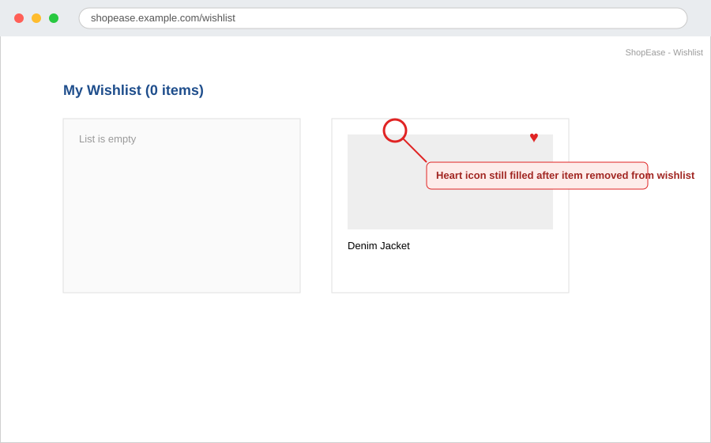
Figure 4 — Wishlist shows 0 items, but product icon still appears filled.
BUG-05 — Search with special characters returns server error
Field | Value | Field | Value
Severity | Major | Priority | High
Module | Search | Environment | Chrome, Desktop
Session | Session 2 | Status | Open

Description
Entering certain special characters into the search bar causes the results page to return a server error instead of a graceful 'no results found' message, indicating a lack of input handling on the search query.
Steps to Reproduce
1. Navigate to the ShopEase homepage.
2. Enter special characters such as %#@!! into the search bar.
3. Press Enter or click the search icon.
4. Observe the resulting page.
Expected Result
The search should either sanitize the input and return a 'no results found' message, or ignore unsupported characters gracefully.
Actual Result
The page displays a '500 Internal Server Error' message, exposing an unhandled server-side error to the end user.
Evidence
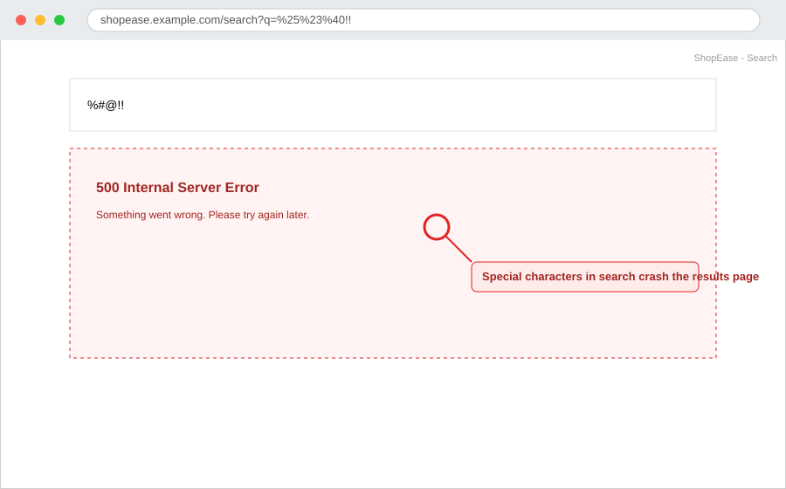
Figure 5 — Search results page showing an unhandled server error.

4. Bug Summary
A total of 5 defects were identified across the three exploratory sessions: 1 Critical, 3 Major, and 1 Minor. The distribution highlights that pricing consistency and error-handling on user input are the areas most in need of attention before release.
ID | Title | Module | Severity | Priority | Status
BUG-01 | Coupon discount applies twice on rapid double-click | Cart / Coupons | Major | High | Open
BUG-02 | Price mismatch between product page and cart | Product / Cart | Critical | High | Open
BUG-03 | 'Place Order' button partially clipped on mobile (375px) checkout | Checkout / Responsiveness | Major | Medium | Open
BUG-04 | Wishlist heart icon doesn't update after item removal | Wishlist | Minor | Low | Open
BUG-05 | Search with special characters returns server error | Search | Major | High | Open

5. Conclusion
This exploratory testing exercise uncovered 5 defects that scripted, happy-path test cases would likely have missed — including a critical pricing inconsistency, unsafe handling of special-character input, and two state-synchronization issues (coupon double-application and wish-list icon state). Testing by deliberately probing edge cases, rapid repeated actions, and unusual inputs proved effective at surfacing issues rooted in timing, validation, and state management. These findings should be prioritized for fixes ahead of ShopEase's release, with the pricing mismatch (BUG-02) and unhandled search error (BUG-05) addressed first given their severity.

